ABC Company Portfolio Project – Tableau

Jon Brookins

ACT 450 Auditing

Colorado State University – Global Campus

Dr. David Adu-Boateng

December 1, 2019

ABC Company Portfolio Project – Tableau

ABC Company has chosen to perform an audit for years 2009 – 2012 using data analysis. Sales data from ABC Company is a treasure trove of data that includes all pertinent information to perform a complete visualization and analysis. All sales data was provided in an Excel document. Tableau is the analytical program used to analyze sales data for ABC Company.

**Sales Revenue Analysis**

The first objective using ABC Company sales data is to sort sales revenue from largest to smallest by sub-category. The largest selling item in ABC Company’s inventory is the Canon PC940 Copier. There are 13 inventory items with zero sales.

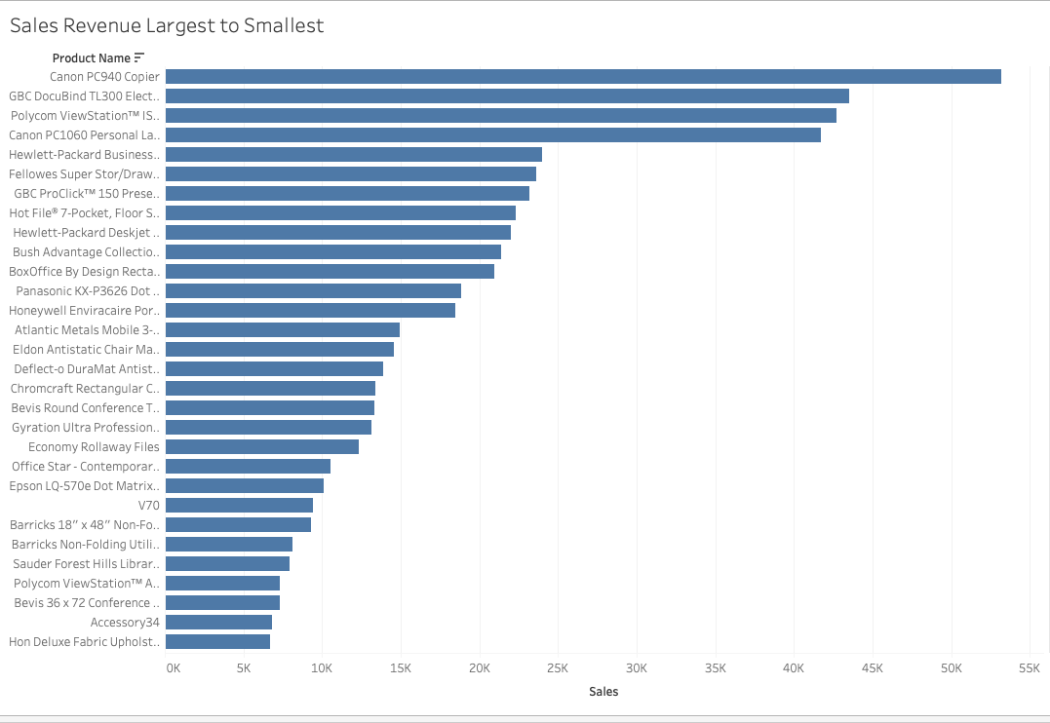

Stratification is a technique used in audit sampling to ensure that accounts with the largest monetary amounts will be selected in the sampling process. Individual accounts are stratified based on their dollar amount. In the case of ABC Company, the stratification will consist of the sales revenue. ABC Company had a total of 8399 sales transactions between 2009 and 2012. My first calculation was to find the average amount of each transaction. Each transaction averaged $1775.88. Next I calculated the standard deviation. The standard deviation equaled 3585.050525. I then calculated the confidence level at 95%. The confidence level at 95% equaled 76.67072695. The upper limit equals the confidence level at 95% plus the average transaction, $1825.55. The lower bound of transactions equals the confidence level at 95% subtracted the average transaction, $1699.21.

Stratification helps with audit efficiency. The audit may be improved if the auditor stratifies a population by dividing it into subsets. The objective of stratification is to reduce the variability of items within each stratum. Stratification reduces the subset size without increasing sampling risk. When the auditor performs tests of details, revenue is often stratified by dollar value. Stratification allows more audit effort to be focused on larger value items. Larger dollar items tend to contain the greatest potential for misstatement related to overstatement.

The ABC Company has a significant number of transactions that range between $1825.55 and $1699.21. It would be important for the auditor to manually check transactions that fall significantly outside of these bounds. The auditor would compare quantity sold, average sales, and inventory count to determine any anomalies.

**Revenue Recognition for 2012**

Revenue recognition is an important aspect of auditing. Improper revenue recognition could lead to financial statements that misstate income for a fiscal year. An important subset of audit objectives is sales cutoff. Sales cutoff ensures that sales are recorded in the proper period.

ABC company shipped sales on January 1, 2013 for $434. While $434 is not a significant amount, it is important that financial statements correctly state income for a given year.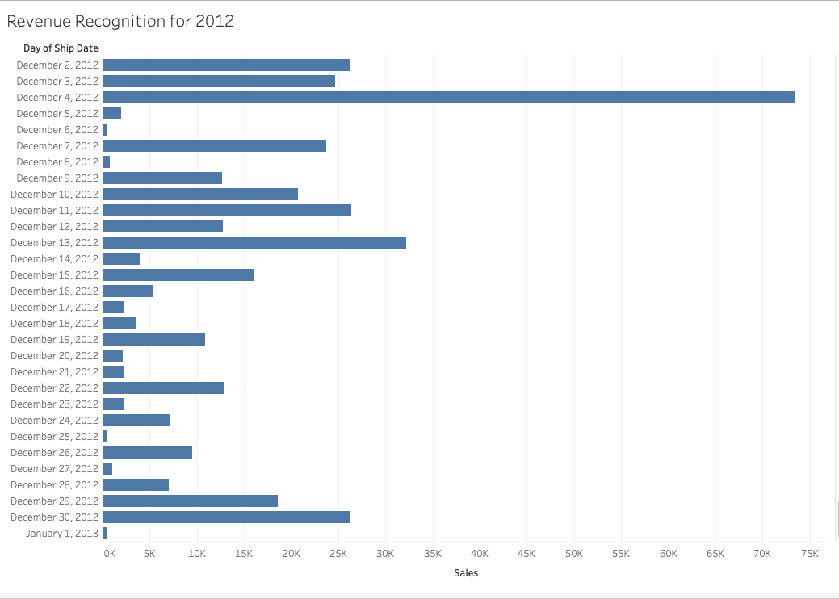

**Market Segment**

Market segment of sales is an important aspect to determine ABC Company’s primary source of income. I used Tableau to calculate product category and consumer market region. The highest sales by product category is technology at $5.9 million. The category with the lowest sales volume is office supplies at $3.7 million. The top two regions in Canada for sales volume of consumer office supplies are Ontario and the west region. An emerging market for ABC Company is Nunavut. ABC Company should focus on expanding its market share in Nunavut.

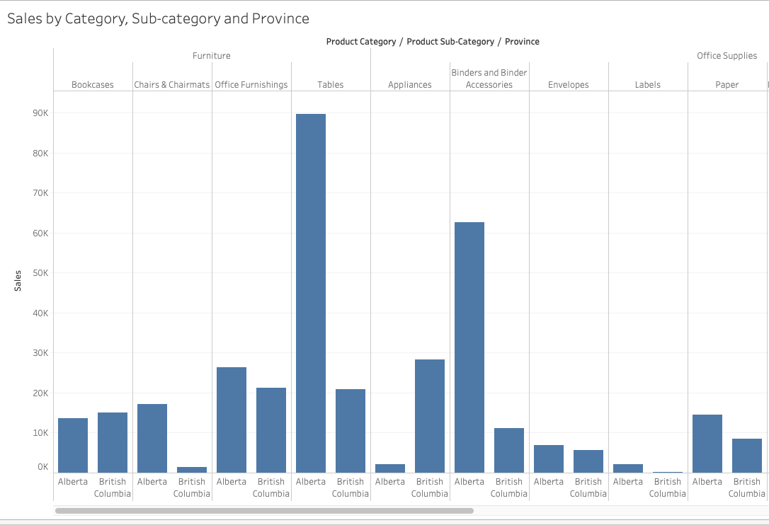

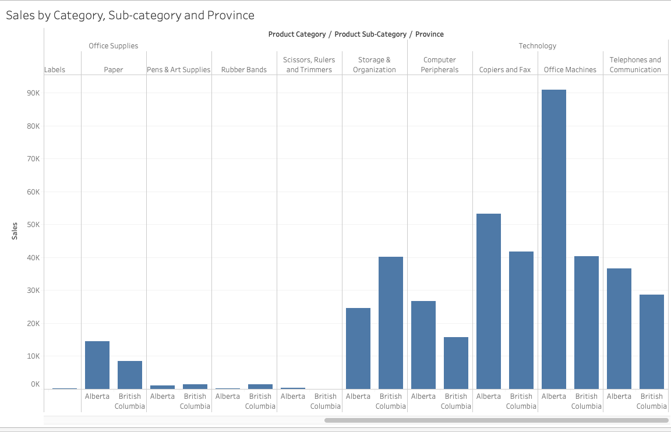

**Sales by Month and Year**

The year with the highest sales revenue is 2009.

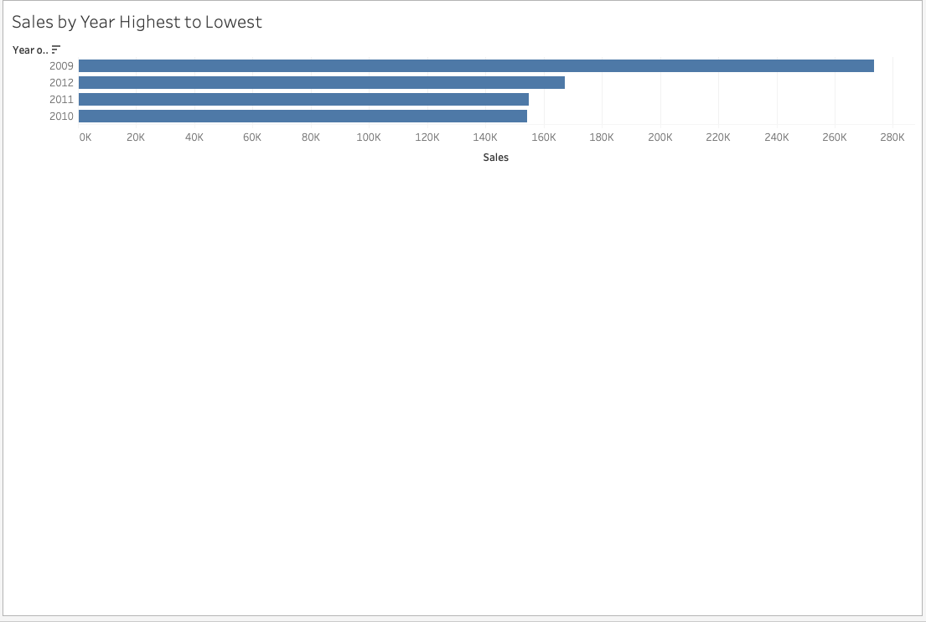

When observing the four years of sales data, January 2009 is the highest in terms of sales.

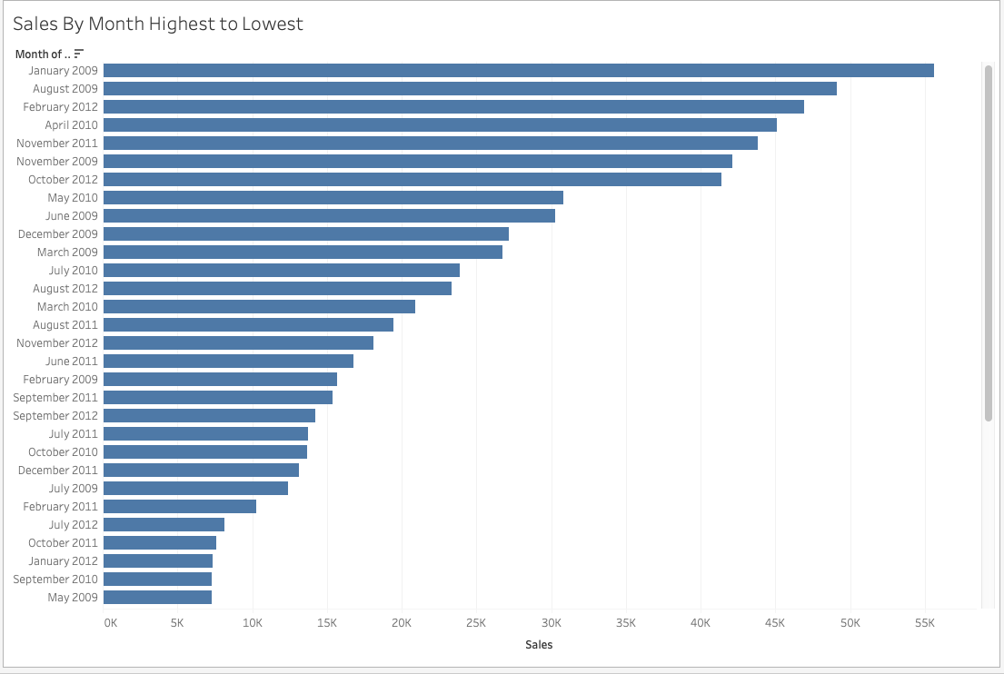

**Sales of Furniture**

Tables in the category of furniture yield the lowest profit.

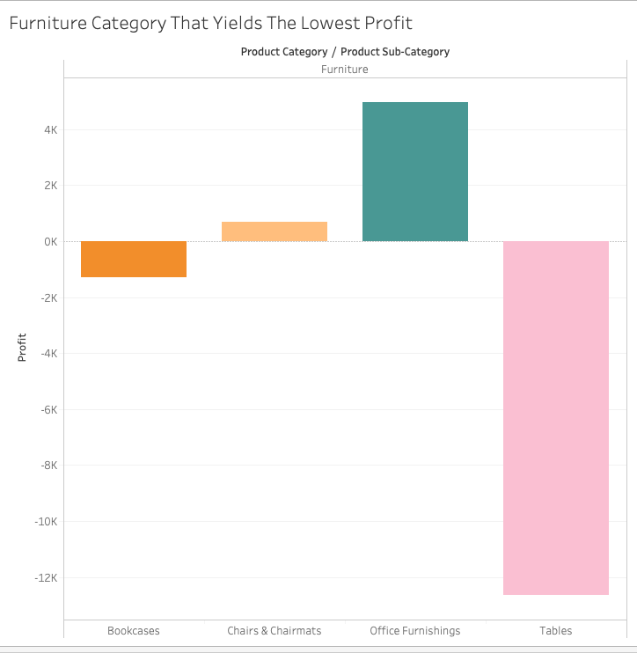

**Sales Forecast**

Using sales data from 2009 – 2012 Tableau is able to forecast sales for fiscal year 2013 by category.

Based on our information Tableau has forecasted the following for sales in 2013 by category:

* Furniture $1,280,678
* Office Supplies $ 992,122
* Technology $1,680,738

Sales forecasting enables ABC Company to better plan for supplies, labor and inventory in 2013.

Conclusion

Data analytics is becoming more important in audit functions. Tableau is able to handle significant amounts of data and drill down important facts for auditors. This information allows auditors to focus on materiality in their audit functions. An item of interest for ABC Company to investigate would be the significant swings in profit related to the furniture category. ABC Company should examine product sub-categories that have zero sales for the year. They would be able to trim inventory by deleting these items from inventory in the future.

References

Appelbaum, D., Kogan, A., & Vasarhelyi, M. (2017). Introduction to Data Analysis for Auditors

and Accountants. The CPA Journal, 7–15. Retrieved from http://search.proquest.com/docview/1897268316/

Schneider, G., Dai, J., Janvrin, D., Ajayi, K., & Raschke, R. (2015). Infer, predict, and assure

accounting opportunities in data analytics. Accounting Horizons: a Quarterly Publication of the American Accounting Association, 29(3), 719–742. https://doi.org/10.2308/acch-51140

Tysiac, K. (2017). Using audit data analytics in performing a risk assessment procedure.

Retrieved from https://www.journalofaccountancy.com/news/2017/dec/using-audit-data-analytics-for-risk-assessment-201717981.html.

Understanding the entity and its environment and assessing the risks of material misstatement

(redrafted). (2010). Journal of Accountancy, 209(4).